Green Travel: Monitoring and Adapting Services for Metro El-Riyadh using analytics and big data techniques

1.High level design and CI.

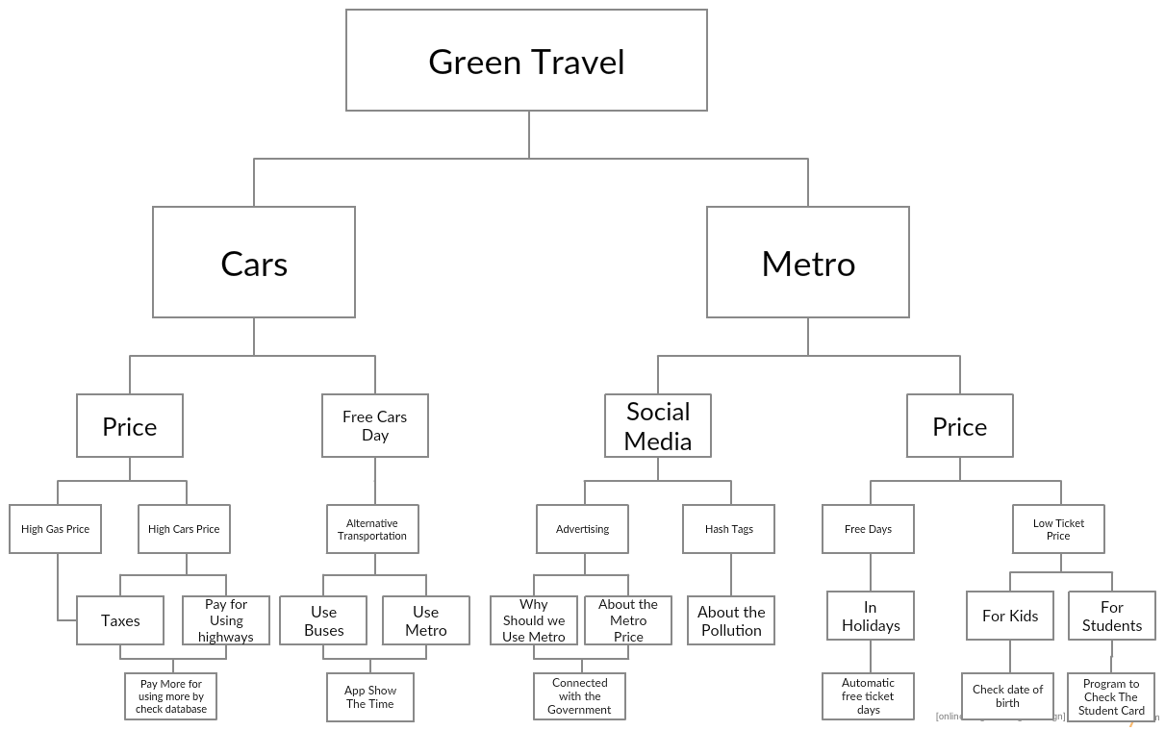

2. Screen shouts and implementation

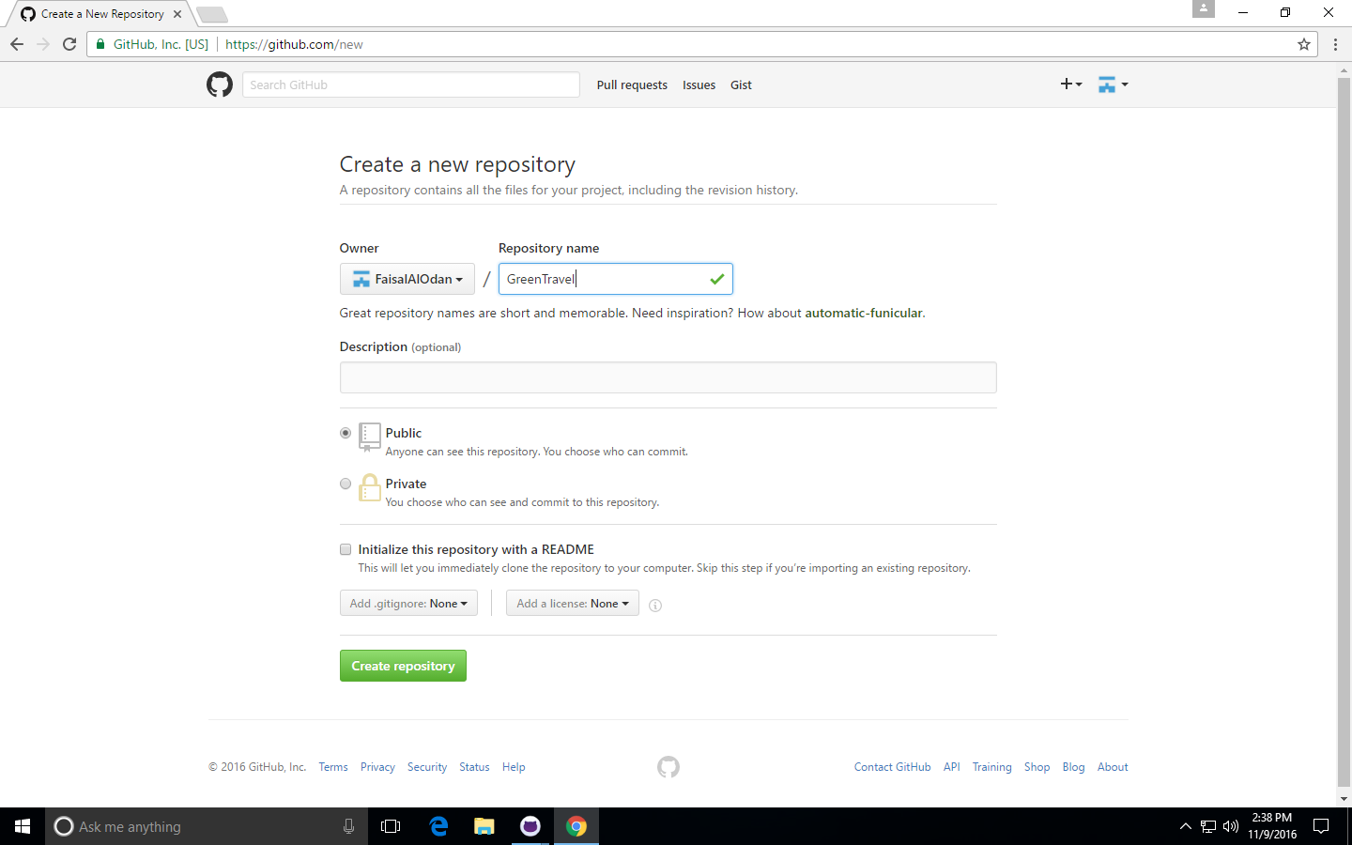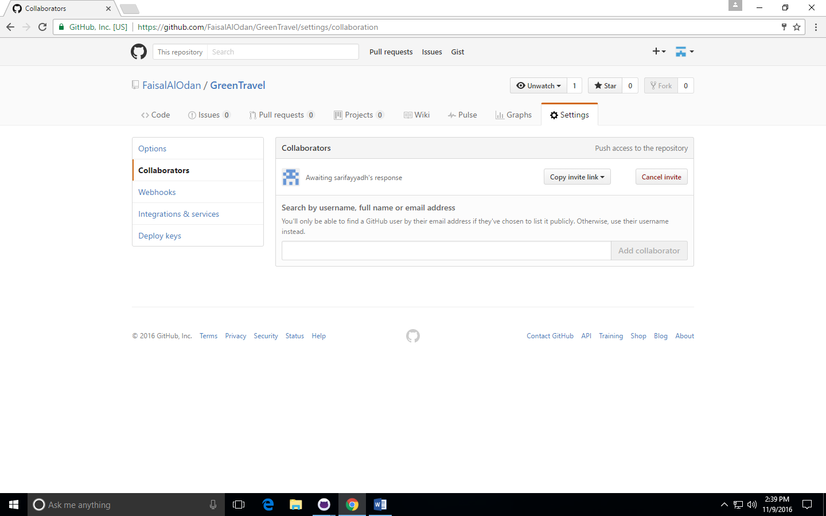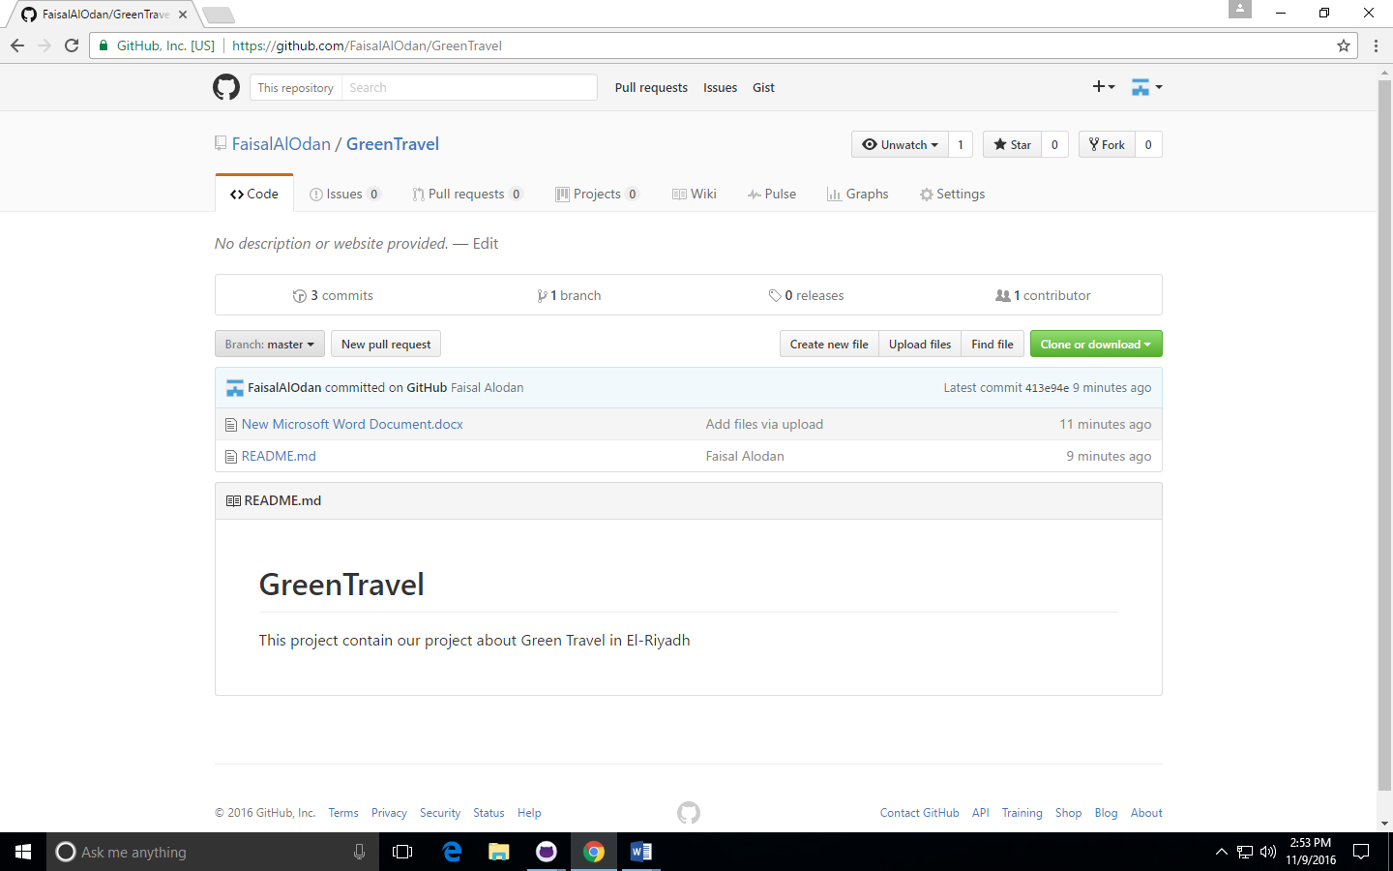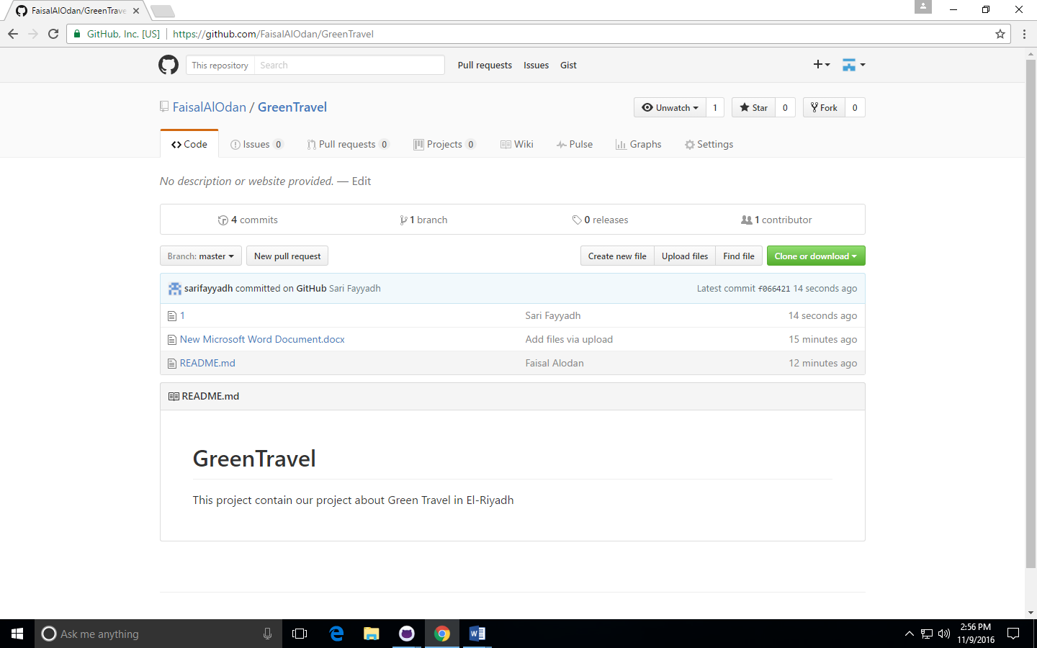

Notes: Assignment 1 have been submitted before for both of us on LMS….